**Date : 21.09.2022**

**Homework : How to compile and execute a C++ program in UNIX / LINUX ?**

**change the permission of directory and then use ls command.**

**THE COMMANDS COVERED ~~**

**Rmdir <dir name> :** Removes the directory

**Rm <file name>** : removes the file

**Ls -a :** enlist the whole list of current directory including hidden file

**ls -lh :** gives data in terms of file size in human readable format

**ls –lhs :** displays the file in descending order

**ls –p :** identify directory easily by marking the directories with slash (/) line sign

**ls –r :** used to print list in reverse order

**ls –i :** used to show the meta data about the file (prints the i node number ; linked files have same node number)

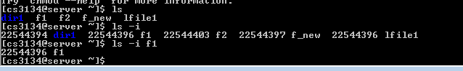

**ls –lX :** groups the file with same extensions together in the list

**Cal :** displays a calendar of the specified year or month

**Cal <year> :** displays a calendar of the specified year

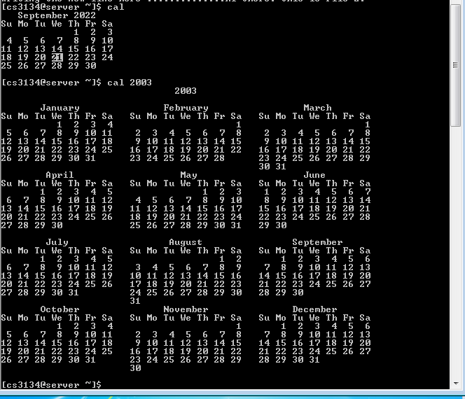

**Rm :** provides a way to insert remarks (that will not be acted on) into a batch file

**Man :**  used to display user manual of any command that we can run on the terminal

Shift+q : exit the manual

**Cp :**  copying files from one location to another

**vi <file name> :** enter contents into file

I : enter the insert mode in editor

Esc (in nano editor) ` : exit the insert mode

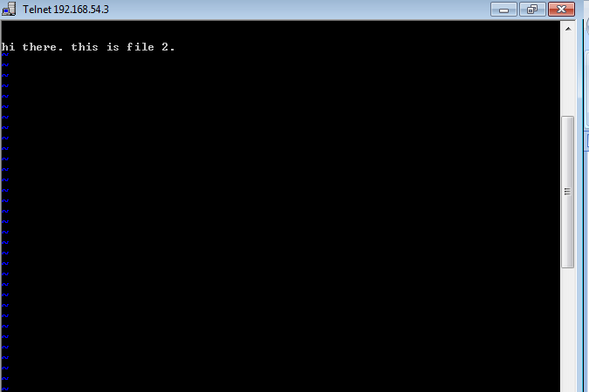

Shift + q : exit the editorp

**-wq : w** writes DATA from buffer into file and q is for quitting the editor

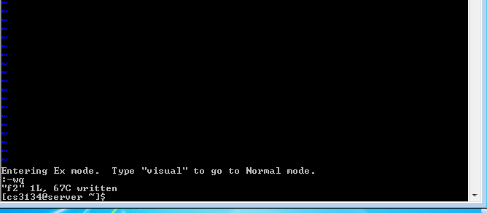

**Cat <file name> :** contents of file shown



**Cp <source file name> <destination file name – not created> :** copy the file with new name in same directory

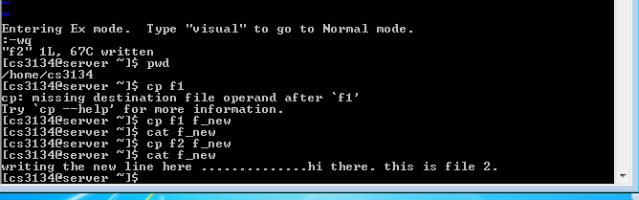

**First determine the complete path where you want your file to be copied**

**Cp <source file name> <destination file address/name> :** copy the file with new name in same directory

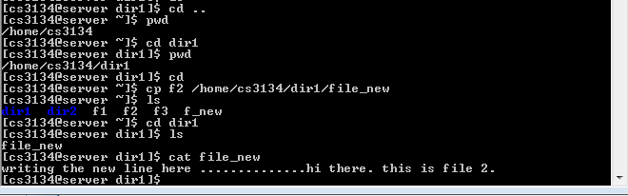

**ABSOLUTE AND RELATIVE PATH IN UNIX/LINUX**

**Absolute** starts from root and it goes as root/user/program/file/directory

**Relative path** refers to the path with respect to the relative position or current position in file.

**Ln <source file> <new file for link – not created> :**  create links to files or directories

**(the link count of the linked files changes from 1 to 2)**

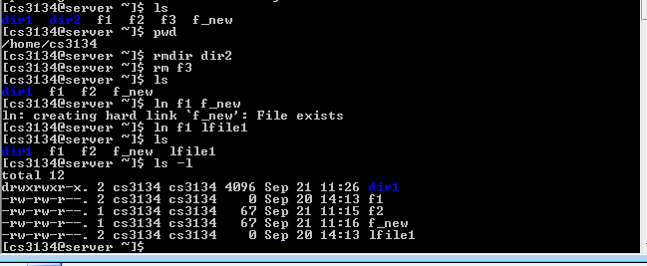

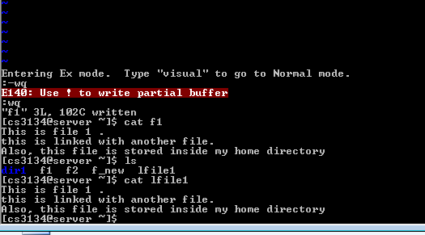

**Chmod < > <permission : r/w/e> :**

**User community in linux :**

**Mv <source file> <destination file> :**  when both the files are in same directory then mv works like rename otherwise.

Ls –I :